# **4th Story – Attention: Stolen Treasure**

In the annals of the *Cyber Village*, the fourth tale—titled *Attention: Stolen Treasure*—begins in the bustling cyber bazaar, a digital crossroads of trade and deceit. From the dawn of communal gatherings around ancient fires to the sprawling digital forums of today, the art of advertising has been a constant, calling out to the collective consciousness of societies.[1] Historically, the resonant call of town criers once harnessed the power of the voice to captivate, their words carrying the weight of commerce and the messages of political change. Evidence indicates that ancient Egyptians made use of papyrus to create sales messages and wall posters.[2] Artifacts bearing commercial messages and political campaign notices have been found in the ruins of Pompeii and ancient Arabia. In ancient Greece and Rome, papyrus was frequently used for lost and found advertisements. Moreover, wall or rock paintings served as a method of commercial promotion, a form of advertising that persists in many parts of Asia, Africa, and South America to this day.

The use of commercial and non-commercial messages to attract attention is an indication of an organized society where information is used to connect individual community members. A small group of the economically-, politically-, and socially-privileged targets a large and underprivileged group. Advertising media is an essential attention-grabbing channel that embodies a stratified society model, where those who dominate the distribution of information are able to impose their purposeful messages on various target groups. Historically, attention is an important target of advertising practitioners from the initial period. However, the techniques of appropriating the attention of the community have constantly changed in different periods of time.The more *sophisticated* the attempts to appropriate attention, the more intense the human sufferance becomes, and the more the *unconscious tension of societies* increases.

## **Tracing the Stolen Treasure**

We journey back to a time before the airwaves buzzed with the relentless pursuit of consumer attention, a time when advertisements spoke directly and sparingly to their small, local audiences. Back then, with their modest production capabilities and limited distribution, advertisements were woven intimately into the fabric of daily life, often carrying a weight of reliability that modern commercials can scarcely claim. Each message served not just as a beacon for goods or services but as a thread in the tapestry of communal knowledge. In these communities, the scarcity of information did not cloud judgment but rather sharpened it, allowing for a direct and discerning engagement with the few advertisements that dotted the landscape. This era, marked by an inherent trust in the sparse promotional messages, contrasts sharply with today's barrage of often dubious claims, inviting us to ponder the profound shifts not only in how products are sold but in how truth itself is marketed and consumed.

As an example, the first printed advertisement was a bronze plate dating from the Song Dynasty (10th to 13th AD). It used to print posters on a square paper with a rabbit symbol and the words *Jinan Liu's Fine Needle Shop*.[3] Written above and below the copper printing plate were the sentences ‘We buy high-quality steel rods and make fine-quality needles, To be ready for use at home in no time’. These messages identified the clear purpose of drawing customers’ attention and establishing a robust reputation for the shop.

**

Figure S4. 1: Page advertisement from Jinan Liu’s Fine Needle Shop, Shandong Province, Song Dynasty. ©depts.washington.edu.

In Europe, when the towns and cities of the Middle Ages began to grow and the general population was yet unable to read, instead of signs that read *cobbler, miller, tailor, or blacksmith,* images related to their trades would be used, such as a boot, a suit, a hat, a clock, a diamond, a horseshoe, a candle or even a bag of flour.[4] Most of these advertisements directly introduce the products and services to to attract the attention of customers.

In the 18th century, advertisements began to appear in the English weekly newspapers. These early print advertisements were used to advertise books and newspapers, which became increasingly affordable with the advancement of the press.[5] Parallel with this efficient production and distribution of commercial information, the emergence of false or *quack* advertisements was observed in the field of promotions. False pharmaceutical advertisements became a serious social problem, and skepticism about advertising arose, leading to the development of regulations for advertising content.

By the middle of the 19th century, mass production had become commonplace as a result of the commercialization that connected continents, this driven by colonialism throughout the globe. Printing techniques developed rapidly. The demand to promote products and services lead to the birth of the advertising industry. In this period, biscuits and chocolate became products for the masses. The British biscuit manufacturers were among the first ones to introduce the idea of a brand to distinguish between grocery products.[6] Huntley & Palmers cookies, one of the first global brands in the world, were sold in 172 countries in 1900, and their global reach was reflected in their advertisements.[7]

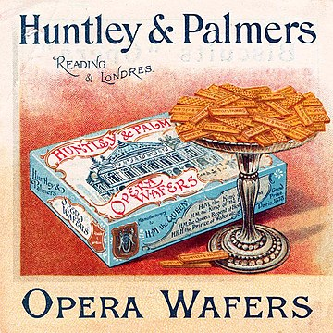

Figure S4. 2: Advertising for Huntley & Palmers wafers c. 1890 ©Wikimedia Commons.

La Press, one French newspaper, was the first to set up paid advertisments on its pages in June 1836. This advertising service resulted in lower pricing for the newspaper, expanding its readership and increasing profitability. Soon after, this formula was copied by other news publishers.[8] In the 1840s, Volney B. Palmer founded the base of the modern advertising agency in Philadelphia. In 1842, Palmer began to purchase a large amount of space in various newspapers at discount prices, and he then resold the space to advertisers at higher prices. At that time, the copy, layout, and artwork was still prepared by the advertising companies. As a matter of fact, Palmer was the earliest space broker.[9] The spatial element in newspapers had become, by then, a commodity in the supply chain for the advertising production process.

N.W. Ayer & Son's first full-service advertising agency was founded in 1869 in Philadelphia. Ayer & Son offered to plan, develop and execute complete advertising campaigns for its clients. In the 1900s, the advertising agency had become the creative planning provider. Advertising established itself as a profession.[10] In the meantime, in France, Charles-Louis Havas expanded the services of his news agency to include advertising brokerage, making it the first French group to organize advertisement space in the newspapers.[11]

Public spaces were also gradually commercialized into areas for advertising. Signs appeared in stores and advertisements in newspapers while advertising posters were produced and displayed throughout the city. The promoted posters also appeared on public transport vehicles to attract the attention of passersby in the early part of 20th Century.[12]

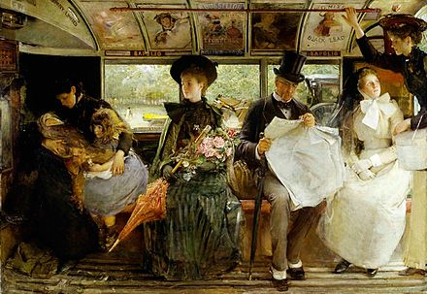

Figure S4. 3: George William Joy's depiction of the interior of a late 19th century omnibus conspicuously shows the advertisements placed overhead. ©Wikimedia Commons.

By the beginning of the 20th century, targeted advertising tactics had been introduced through the practice of Thomas J. Barratt of London, known as *the father of modern advertising*.[13] Consulting for the Pears soap company, Barratt formed various influential advertising campaigns to promote the products of the company, which involved targeted slogans, images, and phrases. One of his slogans, ‘Good morning. Have you used Pears' soap?’ was very well known in its day and throughout the 20th century.[14] In 1882, Barratt collaborated with the English actress, Lillie Langry to create the poster-girl for Pears; this role resulted in Langtry becoming the first celebrity to endorse a commercial product.[15] Being the company's brand manager in 1865, listed as the first of its kind by the Guinness Book of Records, Barratt introduced many of the crucial ideas that lie behind successful advertising, which were circulated widely in his time. Thomas J. Barratt emphasized the importance of a strong and exclusive brand image for Pears, highlighting the product’s availability through saturation campaigns. He also considered the importance of constantly reevaluating the market for changing tastes and mores. In 1907, he asserted that ‘tastes change, fashions change, and the advertiser has to change with them. An idea that was effective a generation ago would fall flat, stale, and unprofitable if presented to the public today. Not that the idea of today is always better than the older idea, but it is different – it hits the present taste.’[16]

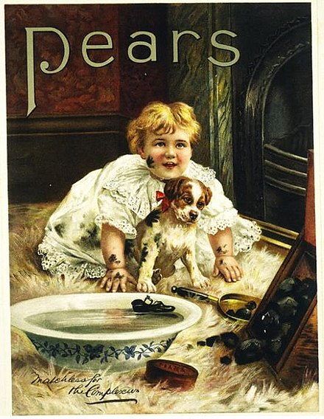

Figure S4. 4: Poster for Pears soap created under Thomas J. Barratt's leadership, 1900. Victoria and Albert Museum, London ©Wikimedia Commons.

In the late 19th and early 20th centuries, the development of the 1st and 2nd industrial revolutions initiated a mass production period which eventually led to overproduction. Consequently, the supply of goods would grow beyond consumer demand. To be able to sell products, businesses began to use advertising as a means to bring their attention to and persuade customers to purchase. Modern advertising flourished during this period. The sophisticated advertising tactics that aimed to manipulate consumer spending have contributed to the formation of modern consumerism. From that time onward, consumer attention has been captured by business interest. Various scholars argued that ‘pre-twentieth-century advertising is almost portrayed universally as a simple announcement, contrasted with the cunning sophistication and subtlety of contemporary versions.’[17]

In the 1910s and 1920s, advertisers in the US applied the doctrine that human instincts could be targeted and influenced, which *sublimated* into the desire to buy goods.[18] This is the mass manipulation method initiated by Edward Bernays, nephew of Sigmund Freud and founder of modern public relations, who was previously mentioned in Post 2 of this writing. The core of Bernays' communication philosophy is *linking* mass-produced goods to the *unconscious desires*; it's all about directing *consumer attention* to their *inner selfish desires*, and the media will suggest ways to satisfy those desires with solutions, products, and services.[19] Influencing human instincts by tactical scenarios has been the most profound intention of advertising from the 20th century until the present.

In the early 1920s, radio stations were founded firstly by radio equipment manufacturers, and then non-profit associations such as schools, clubs, and civic groups also installed their own stations.[20] Retailers and consumer goods manufacturers quickly discovered the prospect of radio to reach consumers in their homes, and soon these businesses adopted advertising techniques through this medium. Slogans, mascots, and jingles became familiar on the radio in the 1920s and television in the early 1930s.[21] Capturing public attention with sound became the most prevailing advertising method of the early 20th century. Advertising revenue in developed countries such as the US has increased rapidly since that time. There is recorded information – such as in the 1920s, under Secretary of Commerce Herbert Hoover–about the American government remarkably compelling advertising. Hoover himself transmitted an address to the Associated Advertising Clubs of the World in 1925 called ‘Advertising is a vital force in our national life.’[22] In October 1929, the head of the U.S. Bureau of Foreign and Domestic Commerce, Julius Klein, confirmed that ‘Advertising is the key to world prosperity’.[23] According to a 1933 European economic journal, this was part of an *unparalleled* collaborative situation between business and government in the 1920s.[24]

The rise of mass media allowed brands to bypass retailers by advertising directly to consumers. It was a paradigm shift that forced manufacturers to focus on brands and to stimulate the need for understanding purchasing habits, usage behaviors, and the needs and aspirations of consumers.[25] The first series of radio drama was financed by soap producers. The genre became known as a soap opera.[26] Before long, radio station owners realized that they could increase advertising revenue by selling 'airtime' in small chunks of seconds or minutes that could be sold to multiple businesses. By the 1930s, these packets of time for advertising became well known and were being sold by the station's geographical sales representatives. Starting from the era of radio advertising until today, the *golden times* or *prime time* has been generally sold at the highest prices which has been associated with the intensity of social attention.[27]

By the 1940s, manufacturers began to notice how buyers developed personal relationships with their brands in a social/psychological/anthropological sense.[28] To collect consumer purchasing information, advertisers began to use motivational research and consumer research. For example, the forcefully branded campaigns for Chrysler and Exxon/Esso used insights-drawn research methods from psychology and cultural anthropology, which opened some of the most enduring campaigns of the 20th century.[29]

In the early 1950s, the Du-Mont Television Network initiated the modern practice of selling advertising time to multiple sponsors. In some cases, sponsors exerted intensive control over a show's content, allowing advertising agencies even to write TV shows themselves.[30] The public interest and attention have been directed to constructed program scripts. From then on, advertisements shifted significantly from direct to indirect persuasion methods.

By the 1990s, the emergence of the internet ushered in a new period in advertising techniques. The attention of society began to shift from offline spaces to online spaces, and desktop advertising was born. The appearance of ad servers drove the online advertising development that contributed to *the* *dot-com boom* of the 1990s.[31] Most businesses operated solely on advertising revenue. The principal part of desktop advertising in the early period of the internet age utilized contextual advertising shown on website interfaces, banner advertising, pay-per-click text, and e-mail marketing. Through these ad forms, page owners could find additional revenue streams to support their content. For instance, the online service Prodigy displayed banners at the bottom of the interface to advertise Sears products.[32] In 1993, the first clickable web ad was sold by Global Network Navigator to a Silicon Valley law firm.[33] Web banner advertising was considered the mainstream of online advertising when HotWired, the online component of Wired Magazine, and Time Warner's Pathfinder sold banner advertising to AT&T and other companies in 1994.[34] The first AT&T ad on HotWired had a 44% click-through rate, and instead of directing clickers to AT&T's website, the ad linked to the online tours of the world's most famous art museums.[35]

With the emergence of innovative technologies in the 1990s, the interactivity of advertising methods increased. The ability to measure the reach of advertising entered a new stage, wherein relying on computational statistics had become much more accurate and simpler. The attention of targeted audiences was measured based on user engagement with the online ad. Through methods of stimulating user interaction with the applications—such as mobile apps—the navigating techniques on devices have been continuously developed and lead users into the advertising matrix.

Based on the combination of various tactics and strategies throughout a long period of time, and with the support of technological achievements, the advertising of the 21st century transfers the methods of domination and manipulation into digital formats that are comprehensively *appropriating* public attention, revealing mechanical subtlety, and boosting the development of a *tension society*. The emergence of social networks, smart devices, and virtual assistants has created a deep connection between people and the digital environment. At the same time, it has also created giant storage covering the data of billions of users on the platform. Big data and AI have significantly contributed to supporting the advertising industry in terms of ~~a~~ better understanding the unconscious desires of users. Through investigation of individual profiles, machine learning algorithms have been programmed to send the right advertising messages, at the right time, to target customer psychology and manipulate customer decisions.

To some extent,users have become the victims of the *emotional & psychological trauma* created by consumerism and the digital advertising industry. This trauma manifests as excessive exploitation for attention, bewilderment by intertwined states of euphoria and anxiety, frustration with discontentment with what one possesses, and exhaustion of physical and mental resources. The tension level in contemporary societies is increasing. Stress is considered a common psychological phenomenon in modern humans. According to The US National Library of Medicine, ‘stress is a feeling of emotional or physical tension.’[36] This psychological state is partly rooted in external factors, such as the social environment, and the functioning of the economy, politics, and contemporary culture in which advertising plays a remarkable role.

*The tension caused by visual stress*

‘The power of marketing is always the power of getting someone's attention’[37] – Naomi Klein.

Every day people are faced with visual overload in their environment, an abundance of attention signals. Both online and offline spaces have been invaded, and every single *visual destination* is constantly navigated and dominated. Capturing the attention in public spaces is an essential interest of advertisers. Most bus stops, metro stations, airports, city roadsides are filled with billboards, from large to small, from unlit to lit, from printed posters to digital billboards. Regularly, there are advertising spaces seatbacks of trains and buses as well, where people are forced to stare during their journeys. Institutions and universities also allow private companies or corporations to display products and sell goods in their premises. Several coffee chains have even branded themselves as the name of libraries. For example, Starbucks cafe has appeared in the libraries of university around the world.[38] Their logos and signs are ubiquitous, especially in public places that attract the most views. According to Naomi Klein, the author of the book *No logo****,*** the invasion of the large franchise has created a *no space* society where people have no right to privacy, even in public spaces.*[39]* Plenty of areas that used to be public spaces, have become just *pseudo-public spaces*. Personal space is also no longer personal because of the aggression of brands and advertisements. People see advertising products attractive images everywhere, in books, magazines, on household items or on devices such as radio, TV, computers and phones.

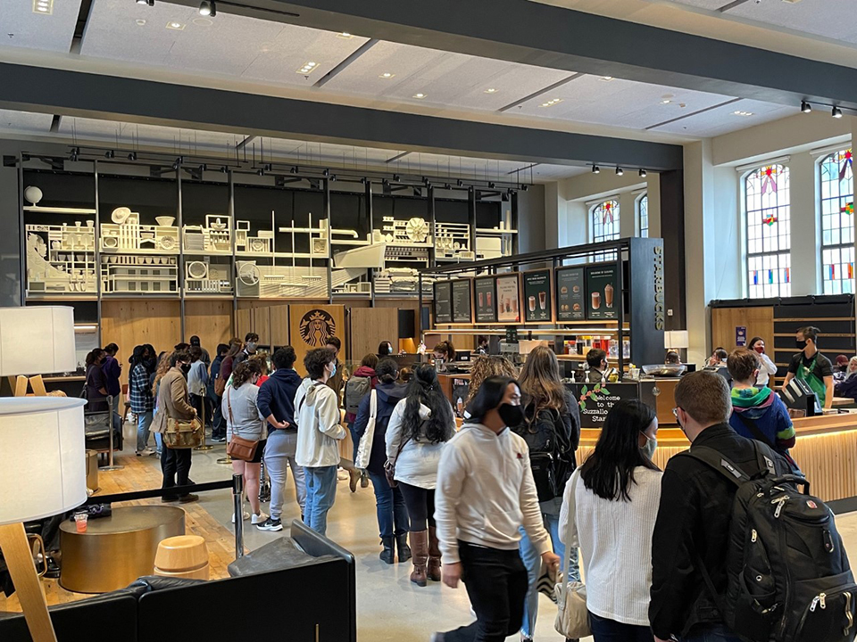

Figure S4. 5: Students wait in line at a Starbucks store inside the Suzzallo Library (Photo by Assunta Ng) ©nwasianweekly.com.[40]

In parallel with the offline environment, all *visual destinations* in cyberspace are also dominated by colours, symbols and moving images of brand signals. All users enter cyberspace with device interfaces, where the logo of the digital brand is first displayed. Following is the appearance of a series of icons, the other visual signal, that is targeting the attention of users. Advertising on website interfaces has become an unavoidable familiar element for users. Email and spam advertising are frustrating many people. Pop-up advertising on entertainment service interfaces and social networks has become the most obvious stressor that millions of internet users now face. The intensity of advertising signals at all times and in all places is a salient factor that contributes to stress experienced in contemporary society.

The colorful world has became the racetrack of brands. Color is a concept that has been constructed through human perception. Brands attempt to appropriate specific types of color and connect them with the perception of customers about their brand. Color has played an important role in branding attention tactics; hence, there is a competitive race between brands to target customers through color. In online space especially, digital codes of colors are used to specifically connect with the identity of brands.[41]

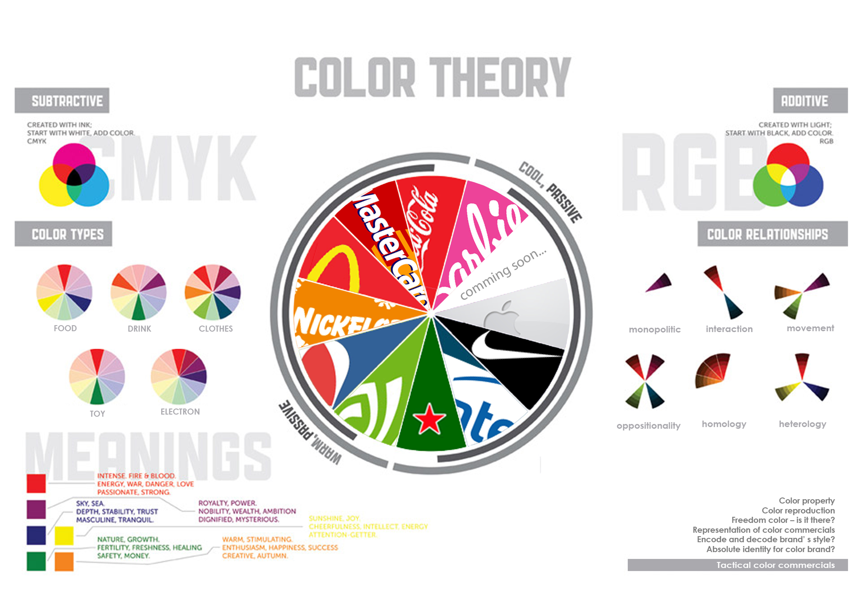

Figure S4. 6: Image Colour theory @ tranguyen project 2011.

Brand identity plays a significant role in differentiating a business from the rest of the competition in the market. Therefore, identity elements are included in the majority of design products. Fashion design, for instance, is using styles, materials and colors to identify their differentiation. Interface design takes graphic details and interactive movements as identifying signals. Various types of designs have paid special attention to highlighting the brand element. Designers have been trained carefully and comprehensively in a variety of visual principles and design methods in order to attract the viewer. The more successful the designs, the higher the visual appeal.

Design strategies are continuously generating new ideas and building impressive images and scripts. Advertising design in particular applies visually attractive methods in order to draw the attention of the viewer through creative and novel elements. In the present, we are being surrounded by designed environments, from living habitats to virtual habitats, and our visual attention is appropriated continuously and professionally.

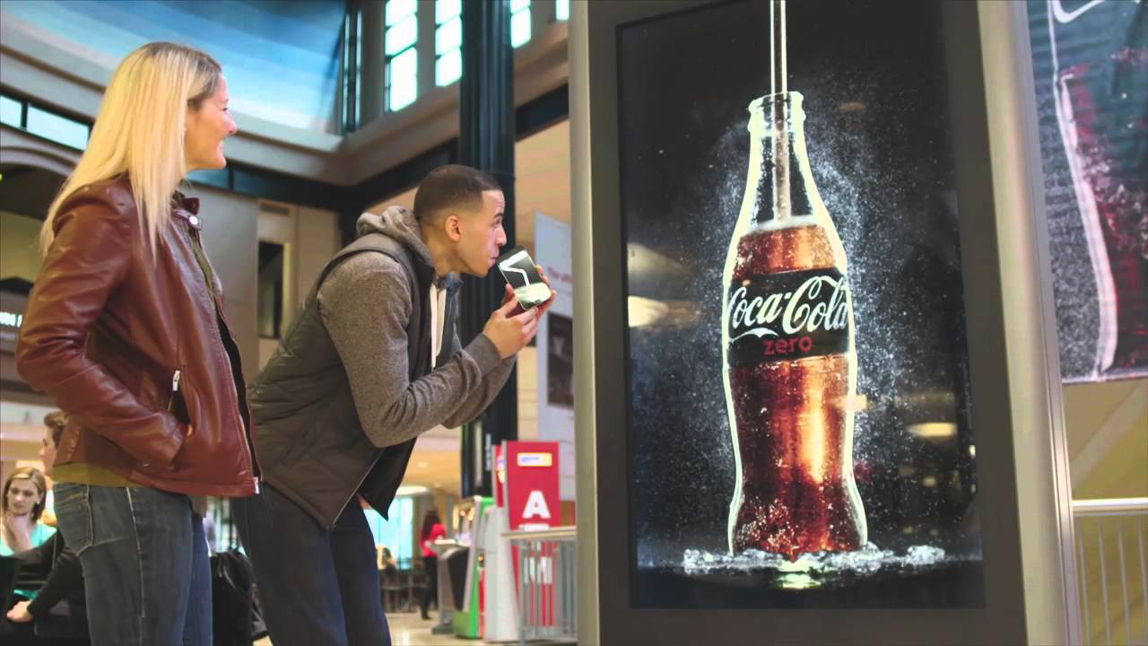

Figure S4. 7: The drinkable TV advertising ©tunedglobal.com.[42]

*Stress for the meaningless struggles*

In addition to the effects of various visual strategies, the metaphorical images, indirect contents and hidden tactics of marketing campaigns also create a constant stress for consumers. With their attention targeted by many things, people face a large amount of detrimental information. French sociologist, philosopher and cultural theorist Jean Baudrillard in his book *Simulacra and Simulation* wrote: ‘We live in a world where there is more and more information and less and less meaning.’[43]

Contemporary society is confronted with a crisis of *information overload*, in which simulacra - images and symbols - begin to take precedence over reality itself. The cultural symbols are challenging the reality, advertising playing a critical role in accelerating the production of these symbols. Through media and advertising campaigns, products and services are skillfully transformed into social cultural representations that pretend to be the essential truth or unconditional needs, thus creating the desire for possession. In other words, ‘advertisements manipulate the relation between ‘meaning’ and ‘reality’ by appropriating pre-existing meanings to add value to unrelated products, and posits methods of decoding their true underlying significance’.[44] For example, to connect with the cultural values, numerous classical paintings have been used to advertise products or services.



Figure S4. 8: Da Vinci’s Last Supper reimagined as a gambler’s table ©tiqets.com.[45]

Local cultural symbols have also been connected regularly with the image of products and services by global corporations. One of my former work, *Cultural Symbols of ‘Tet’ Holiday in Vietnamese Urban Lifestyles on Video Advertising*, introduced the manipulation of corporations on cultural symbols through video advertising in Vietnam.[46] The images of Coca-Cola, Sony, P&G and Unilever have been associated strongly with with the cultural image of the Tet holiday, the New year festival of Vietnamese. Integrating, connecting, and blurring the boundaries between cultural symbols and product images is presented in the interactive work, Cultural Symbol Store, which I exhibited in 2012.

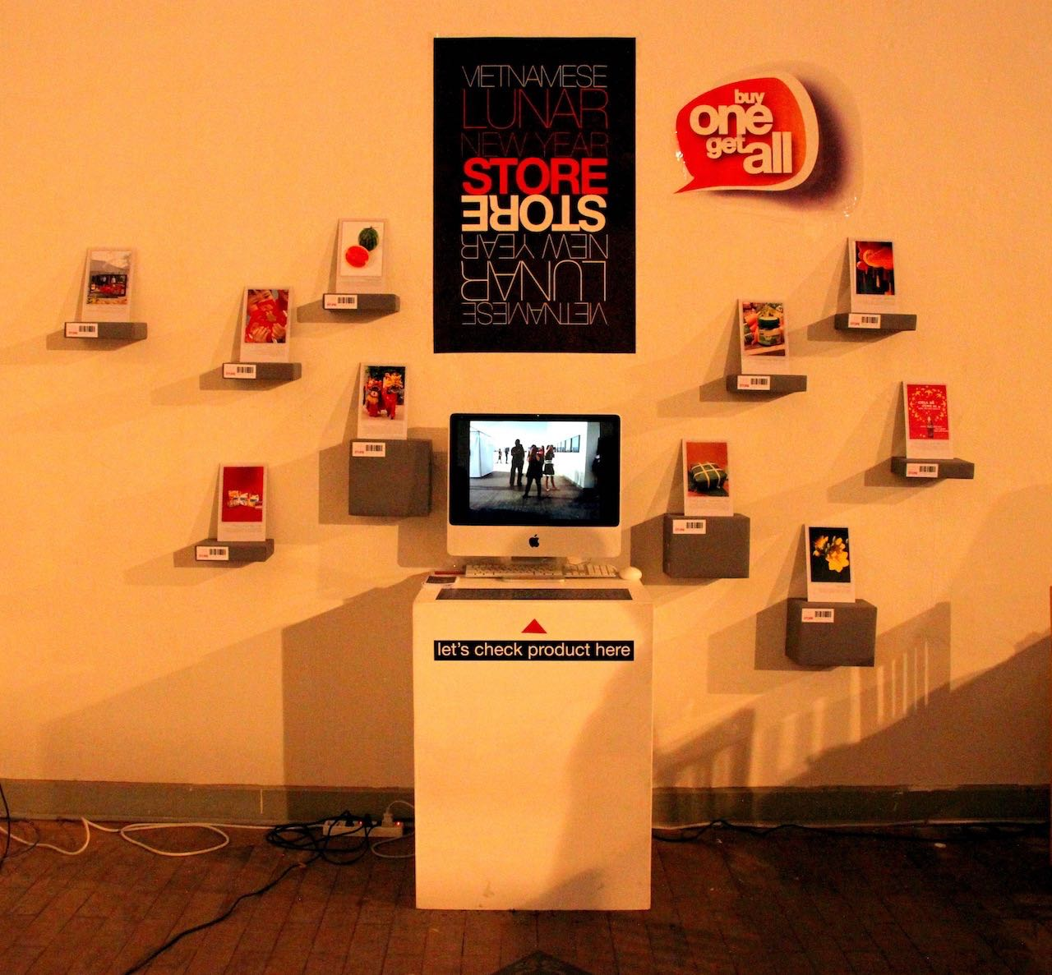

Figure S4. 9: Cultural Symbol Store ©Tra Nguyen.[47]

Movie stars, cultural idols or political personalities are positioned as symbols of beauty, wealth, power and satisfaction, and they have been efficiently used to connect brands and customers from the 20th century to the present. A glamorous super model, an actor in elegant outfit, or a wealthy professional sportsman has become a living symbol for many customers.



Figure S4. 10: Tennis champion Roger Federer stars in Mercedes SUV advertisement. ©al.com.[48]

The constructed social symbols have thus become the basis for defining one’s ego. Consumer *sense of self* is directly connected to the feeling of having and possessing items.[49] The promotional images have effectively linked products, services and social symbols with the ego of the customer. Customers are taught to crave the perfect bodies, elegant looks and luxurious living spaces. All these intend to give customers psychic powers about themselves.

However*,* the present struggle to assert the personal self is not much different from the race to assert the consumer's self*,* the asserting of shopping ability, consumption, and ownership.

Advertising and marketing have created fake relationships between customers and products through symbols. Going beyond the stimulation of demand for specific products, advertising generates consumption as a specific behavior. At the end of the 20th century, people witnessed a significant decline in the importance of instrumental, utility-driven consumption and a remarkable expansion in *symbolic consumption*.[50]

The advertising industry has driven the *sign economy* to bloom, creating a cultural production system based on symbols.*[51]* Advertising has played a social-oriented role, dominating the worldview and lifestyle of the majority of individuals. The *Consumer's Self* has navigated the awareness and actions of each individual. Ownership is the driving force of consumer society. Contemporary life is all about the desire for difference and the expression of identity through the display of sign values. The *no fact* *scenario* of the struggle to assert the individual self has been constructed through images, symbols and icons. In the last paragraph of the book *Ways of Seeing*, John Berger wrote: ‘Capitalism survives by forcing the majority, whom it exploits, to define their interests as narrowly as possible. This was once achieved by extensive deprivation. Today in developed countries, it is achieved by imposing a false standard of what is and is not desirable.’[52]

*Stressed by irrational desires and fears*

For the majority of economic and political planners, masterminding and manipulating the public psyche is the essential method modeled and used since the 1920s until now. The applications of Freudian psychoanalysis to public relations and advertising continuously developed and has become much more threatening today. With the help of machine learning algorithms, the psychological methods are constantly perfected. Public manipulation tactics have been implemented efficiently through intelligent device systems.

Cyberspace has turned human emotions of happiness, satisfaction, anxiety, and fear into a type of product. The unconscious mind is investigated, surveyed, and evaluated by machines based on user data recorded through digital activities. The frequent concerns and interests of users have been recorded through search engines or traces of HTTP cookies. User habits are collected through personal devices, such as information about their routine time, regular travel routes and daily activities. From the information related to the user's personality, the algorithms analyze and make judgments about the characteristics of an individual mindset. The data related to the unconscious mind of each individual is the target product of contemporary advertising. Based on the characteristics of psychological data products, the advertisers adjust the process of producing and delivering advertisements. *Fears of loss* as well as longings for possessions are pushed to the extreme by targeted advertising delivered at the right time and to the right audience. Knowledge of user irrational desires and fears is the basis for *psychological manipulations* to work more effectively and easily.

Online advertising connects minds of users deeply to fake illusions, removing people from their life of reality, they have been guided to associate mostly with the past and worry about the future. In the words of John Berger: ‘Publicity images also belong to the moment in the sense that they must be continually renewed and made up-to-date. Yet they never speak of the present. Often they refer to the past and always they speak of the future.’[53] Advertising frequently projects the deficiencies of the past and the perfect images of the future to consumers. At the same time, online marketing campaigns regularly build up different new social standards and provide various personal social envy to the crowd. Those jealousies create the feeling of craving and add glamor to products and services. Anxiety and jealousy have driven consumers to constantly fill up for what they did not own yet, and it is a uninterrupted process. Prolonged stress and exhaustion are common living conditions in this time and age.

For example, the desire to own the new version of electronic devices has been sprinkled into the minds of consumers by marketers of electronic corporations. Every year, cell phone products of big brands such as Apple, Samsung and Huawei, launch a new model. The advertising campaigns of these products continuously create the desire to own and change devices annually for consumers, especially among young people. New devices are often promoted with new features, and new aesthetic appearances; but most importantly, these updated devices promise to represent the trendiness, stylishness and high social status of the owner. Each year millions of young consumers spend approximately $1300 each to update their self-image by owning new devices. The impressive numbers for iphone sales are a good example: 5 million iPhone 13 series were sold in China on the first day of pre-order in 2021.[54] With the introduction of the new model, the previous one quickly became useless, even though it had been used for only one year. In this case, the essence of uselessness is identified by the incapacity to *show off* rather than by the inability to operate. The device's functionality has been gradually forgotten. The equipment waste and high investment in personal items have led to various social and environmental problems.

Female anti-ageing products are another example of how advertising generates the fear of consumers. Based on the common unspoken fear of getting old, anti-ageing products generate a sense of frustration among the elderly. Navigated by the hidden intentions of advertising, a biased perception of the elderly has been established in contemporary society.[55] Specifically, advertising have a strong influence on the emotions of women, depriving them of their self confidence through prejudices about age. In parallel with creating anxiety from the dangers of ageing, the advertisements also outline *up-to-date styles* with new cosmetics and *age-defying* models and *magical anti-ageing products*. The image of a better appearance in the future repeatedly stimulates the demand for beauty. Various businesses guarantee that the use of cosmetics and beauty services help a woman retain her youth forever.

Furthermore, to increase the attractiveness to and attachment of customers, products and services also apply a number of psychological strategies through different discount and promotion programs. Free products, trial versions, promotional packages, and discount coupons are sent automatically to user accounts. This practice generates unrelenting desires and fear for online shoppers. The online marketing and advertising industry has produced countless emotional states in consumers. For example, emotional states include feelings of excitement generated by free trials, happiness in receiving a particular product or service without charge, and even worries about losing the opportunity for free shipping. All of these marketing programs continuously encourage consumers to spend time and energy on following brands, paying attention to products and chasing free trials, discounts or promotions. Unreasonable desires and anxieties continuously appear while people get hooked on sales and marketing tactics. The more costumers see and buy, the more they find it insufficient for the fulfillment of their own desires. Overall, these marketing scenarios induce stress in the consumers’ unconscious. This irrational feeling of tension exists in parallel with the temporary comfort and excitement created by advertising.

Applying manipulation and deception techniques of commercial advertising, non-commercial advertisements also use similar schemes. Numerous presidential campaigns or referenda in many countries have been dominated and manipulated by psychological methods through data analysis systems. To influence the crowd, political marketing also uses various tactics to control the unconscious minds of people through automatic information systems. During President Trump's campaign in 2016, Cambridge Analytica secured a $15 million investment from Robert Mercer, the wealthy Republican donor, in order to use the machine learning algorithms that could identify the personalities of American voters and influence their behavior. According to former Cambridge employee Christopher Wylie, the company collected personal information from the Facebook profiles of more than 50 million users without their permission, making it one of the largest data leaks in the history of the social network. The breach allowed the company to exploit the private social media activity of a large number of American voters, developing the techniques that underpinned its work on the success of the 2016 U.S. presidential election for Donald Trump.[56] Based on the insight about user psychographic characteristics, Trump’s supported media companies repeatedly sent fake news, smearing the image of Hillary Clinton – the opponent in the election, as well as creating the idea of a frightening future associated with the victory of Hillary’s party. In parallel, positive messages associated with mystical spiritual elements about Trump were also intentionally pumped into social networks, creating excitement, hope, and high credibility for Trump.

The competition between *brands* and the race for power by *political actors* maintains a certain tension within societies. Companies, corporations, and organizations are now investing in and applying new technologies and manipulation techniques. The ability to control large numbers of digital accounts has become the determining factor for social power in the new era.Advertisements surround the users, targeting them with different psychological tactics, and offer users specific information, products, and services. Putting people in a state of being forced to use and forced to choose gives present users *no choice****.*** The permanent fear and desire in the unconscious mind of users, in some cases, could develop into a form of mental illness. Today, consumers have become subjects of psychological tactics applied in sales and marketing.

Consumers have been promised the freedom to choose, and to be cared for and listened to as special guests. However, in reality, they have very few opportunities to make their own decision without the effects of manipulated factors. Consumers constantly struggle with life, exhaust themselves to earn a living, and pay for a fake freedom. The advertising image is a stunning representation constructed by the dominant forces for the play that gives freedom and democracy to the *consumer class*. Yet, in fact, this play tries to cover all of the undemocratic problems in society.

John Berger mentioned that ‘Everything publicity shows is there awaiting acquisition. The act of acquiring has taken the place of all other actions, the sense of having has obliterated all other senses’. However, at the present, consumers are there instead, waiting on the internet space for manufacturers, organizations, socio-political forces, service providers, and media platforms to take their information, exploit and manipulate them freely.

Digital capitalism now occupies both physical and virtual space, controlling both physical and mental properties, appropriating the energy, time and money of users, and dispossessing identities and egos in various ways. Being forced to live in a stressful situation, with *no space, no facts, and no choice* has become a common situation. Advertising is an efficient persuasive product, as well as a tool for manipulation that is an unavoided entity. The effects of advertising strategies contribute to developing a tensive, insecure, and potentially contradictive society. All in all, the unfair and stressful marketing environment could push social distance further and further, and stimulated by many other factors it might introduce instability to future societies.

## **Narcissistic Kingdom**

In the present, the modern ideas of love are about *satisfying oneself*, whereas the traditional ideas of love in a communal way were that people surrender themselves to someone else. Giving oneself up has become a thrilling and frightening thought of the majority of contemporary individuals.[57] The love associated with self-sacrifice is slowly disappearing from life, while *individualism* that first surfaced in the early 19th centurynow influences present-day society.[58]

Social involvement and compassion are popularly considered significant contributing factors to fatigue experienced by people in the face of the complexities and chaos of reality. Give up the thought of sacrificing, and just love yourself; give up the idea of caring and keep enjoying one's personal life with the great world where products and services are always available. This familiar flow of thoughts has generated many concerns for current society.

Media and advertising have preached the idea of self-love throughout the 20th century, and until today. *Be yourself* has become a life motto for many people. Existing independently has been considered as the way to escape from collective exploitation. However, in fact, the majority of contemporary people are bound and exploited by various hidden exploitation forces. Instead of detaching from the exploitation of organizations, institutions, religious and political communities, the ideas of individual independence are appropriated by capitalism. By supporting individualism, capitalist logic intentionally *separates* the crowd, helping the exploiters more efficiently *control* and *manipulate* the public.

Protestants admit that man has a personal relationship with God. This tenet powerfully contrasts Protestantism with the practices of Catholicism wherein adherents are more commonly expected to follow and obey the church hierarchy. The separation of humans from powerful systems is a revolutionary idea. However, this detachment from religious institutions simultaneously generates another form of attachment. In *The Protestant Ethic and the Spirit of Capitalism*, Max Weber cited the Protestant idea of a personal relationship with God as one of the main motivations that allowed capitalism to emerge.[59] The detachment of oneself from the collective also promotes the desire for private property and the hope to become a master.

In Eastern countries, where Buddhism has an enormous influence, the ideas of *introspection, self-cultivation,* and *self-love* are also exploited and amplified by the logic of capitalism. Classical Buddhist philosophy, considered the enlightenment pathway, can be practiced easily through various ways. Although the *non-self/egolessness* is one of the important doctrines of classical Buddhism, the popular Buddhist approach that circulates widely on social media seems to be rather different. [60] Brands promote modern populist Buddhist ideas with the following tips: leave the turbulent life; protect all sentient beings; return to the inner self; be friends with oneself; and practice self-love. For example, ‘Touch your heart,’ and ‘Speak your way’ are common slogans in Vietnam.[61]

From East to West, advertising has encouraged all society members to express themselves with these snappy, captivating slogans such as ‘Because I’m worth it’, empowering consumers to ‘Have it your way’and ‘It’s everywhere you want to be’.[62], [63], [64] The advertisement also firmly asserts ‘Your passion, our strength’, and we will stand ‘On Your Side’.[65], [66] In general, contemporary individuals are driven to believe that they hold the care of institutions, organizations, parties, information providers, services, and products. The strong belief in personal power is nurtured daily by propaganda and advertising campaigns.

In addition, at the end of the 20th century, the Cold War period shaped various emerging social phenomena, such as the crisis of social trust, the acceleration in international trade, the advancement of computer science, mass automation and global internet connectivity. To face these remarkable changes, instead of confronting the complexity and chaos of society, the leaders of both private and public sectors have decided to create a *fake* and *simple* social environment.They have simplified society by coding the complex issues in several cases of mass representations, grouping complicated problems into one or two directions to provide solutions. The rigid and inhuman categories of gender, race and ethnicity are clear examples of the irresponsibility of the above mentioned simplistic social management.

Moreover, the organizers and/or controllers have also been very successful in creating social norms through symbols of consumption, building a society consisting of confident and isolated individuals. In *The Society of the Spectacle*, Guy Debord wrote that ‘The reigning economic system is a vicious circle of isolation. Its technologies are based on isolation, and they contribute to that same isolation. From automobiles to television, the goods that the spectacular system chooses to produce also serve it as weapons for constantly reinforcing the conditions that engender *lonely crowds*.’[67]

An unfair society where most interests belong to a small group, and the majority of individuals live in tension, discontent, and instability, is a society with potential struggles and resistance. Obviously, from various events of the last centuries, the rulers and the wealthy owners were threatened by collective power–the dangers of revolutions and class struggles. The failure of the old capitalists warned the contemporary capitalists to be wary of the collective power of the precarious class. The division is an efficient method of restraining the forces of struggle. Therefore, the motivation to divide society, turning society into a gathering of lonely people, becomes the hidden agenda of contemporary capitalist society. In *Media Control: The Spectacular Achievements of Propaganda*, Noam Chomsky also assumed that ‘The rest of the population ought to be deprived of any form of organization, because organization just causes trouble. People have to be atomized and segregated and alone. They're not supposed to organize, because then they might be something beyond spectators of action.’[68]

Individualism has been multiplied as a *psychological strategy* in the current living environment. The enormous capacity of server systems and machine learning methods allows for more efficient implementation of the social divide. Each individual is represented by one or eventually several digital profiles where all their information about demographics, psychographics, and behaviors can be systematically recorded. Once machine learning systems know users better than themselves, digital powers such as media centres or platforms have the potential to easily influence the unconscious mind of the users and navigate their decision. Surrounding the users with numerous means and information, making them love themselves more and more, and encouraging themselves to express their egos while caring for themselves, digital businesses efficiently nurture the consumer self of each individual.

Indeed, contemporary capitalism creates the ideal conditions for consumers to realize slef-love. With only one click, technology delivery services are ready to deliver various commodities to consumers in order to express themselves, from cars to clothes, all manner of *products* that they can use to express their identity. Parallel with user activity, covert personal data mining dominates cyberspace. Employing user information to coordinate advertisements or propaganda messages, influencing user perceptions and emotions, and manipulating user behaviors, all are automatically implemented by algorithms. In the words of many CEOs in Silicon Valley, ‘This is incredibly efficient’.[69] This smooth, seamless process of manipulation by platforms targets the user upon entering cyberspace, placing the user in the ‘You’re done’ situation, like the slogan of Amazon.[70]

The growing significance of individualism and the enormous support of AI technology have fueled the growth of *personalized marketing* and *targeted advertising*. The traits of the promoted product or targeted person are considered the main factors for producing and distributing advertisments. Product and service characteristics are often provided intentionally by the businesses themselves as they are also the advertising sponsors. While personal information is being recorded and exploited non-publicly against the intentions of the users. Individual characteristics are normally formed through demographic information that focuses on race, nationality, economic status, gender, age, generation, education level, income level, and employment status, or psychological traits that focus on consumer values, personalities, attitudes, perspectives, lifestyles and preferences. The characteristics of users can also be recorded through behavioral variables, such as browser history, purchase history, and other recent online activities. At present, personal traits in cyberspace have often been collected and recorded through search engines, websites, social networks, Internet Protocol television, Mobile devices, and Smart electronical devices.

*Personalization* is a common notion for online services strategy today. Usually, the personalized functions are propagated tendentiously as a superior feature for user online experiences.[71] The personalized services, such as personalized search results and personalized advertising are being introduced as tools of miraculous convenience for users. Whenever the users turn on the personalized features of their electronic devices, web browsers and search engines the digital service providers may record user passwords, search history, and the address of the pages they visited. With the activation of a personalized function, the users do not need to log in back and receive targeted information suitable for them. Providers may especially suggest specific products or services that they have been, or will be interested in. The personalization process enables providers to efficiently collect *personal data*, the crucial raw material for the data industry. Personal data is also the backbone of database marketing and the foundation resource of programmatic advertising. A major part of political propaganda and business advertising is applying and exploiting personalized digital strategies because ‘it's incredibly efficient’.

Personalized functions have obviously generated the pleasure and comfort experience for users, which is the reason why users generally rarely hesitate to turn on the personalization features of digital products and services. At the same time, personalization is a persuasive reason for the activities of recording, exploiting, and manipulating user behavior; it is an influential tool in the age of AI information technology.

Using search engines to understand users and reach targeted audiences is one of the most common types of personalized marketing in cyberspace at the present. The searching keywords, the IP address, the HTTP cookies, and interactive behaviors related to users are the clues for knowing customer interests. The combination of account information and browsing data is considered an input source that determines the targeted online display advertising. Advertisements on the web banner or promoted messages on web interfaces are mostly navigated based on data from the search engine’s system. The platform companies do not only use the browsing information of billions of users for delivery advertising inside their system, but they can also commercialize this valuable social statistical information across the data market.

It is a common understanding that the most popular keywords are connected to the most interesting issues, products or services; and it is also believed that the rank hierarchy of search results indicates the reputation of websites, organizations, companies, or products. The top search results are considered the most popular search interests. However, the connection between the business or political reputation and top search results can be fully manipulated. As a matter of fact, the hierarchy of research results are constructed through the influence of the platform’s algorithm and the control of government censors. In numerous countries, the search results are displayed according to the wish of government perception on any specific issue. Otherwise, through investing in advertising on search engines, ad sponsors can also reach a priority position on the search result list. Sponsored search advertisements are sold typically through real-time auctions, where advertisers bid for keywords. Moreover, setting a maximum price for each keyword or bid can include time, language, geography, and other constraints.[72]

Applying targeted advertising within social media is the only other focused strategy of information technology businesses. By encouraging users to post their statuses, share their personal images, and express their emotions (by emotional icons such as like, love or sad) comment on the content of others, send messages and share the posts of others, the providers of these social networking services collect user psychology and behavior information easily. Aside from demographic and geographical data, psychographics and behaviors are the critical data source for the targeted advertising effectiveness. For example, Meta (formerly Facebook Inc) collected massive amounts of user psychology and behavior data from their surveillance infrastructure on the different platforms such as Facebook, Instagram, and WhatsApp. The personal photos from Instagram, the private conversations on WhatsApp and the interactive activities on Facebook are valuable data that can be used to depict the characteristics of a given user.

News Feed is an important feature of Facebook that employs users’ data analysis system to influence the users. Based on insight about customers, this platform shows users the *breaking news* related to them, their friends and relatives, and shared sociocultural information or the *pretended prominent information*. The personalization and customization functions of News Feed are no different from *personalized newspapers* set up by Facebook for each user. The targeted contents and targeted distribution methods have remarkably increased the engagement of users with Facebook.[73] Similar to a tabloid dedicated to advertising, the recent Facebook News Feed is filled with commercial advertisements and propaganda information. Currently, this social network platform publicly allows their general ad partners to use comprehensive lists of various types of targeting options, including user interests, demographics and behaviors.[74]

Statistics of user behavior data are not only the basis for *determining* and *predicting* customer interests and *navigating* how each individual makes decisions, but it is also the *evidence for evaluating* the effectiveness of advertising and the basis for the advertising cost payments.There are several pieces of user information that are used to charge sponsors, such as CPC - cost per click - each time a user clicks on the advertisements; CPE - cost per engagement - cost based not only on an ad unit loaded on the page, but also logging whether that the viewer saw or interacted with the ad; CPV - cost per view on video advertising; and CPI - cost per install, cost of installing applications, most activities active on mobile advertising.

The digital personalized advertising process is usually a complex operation that involves plenty of parties such as publishers, advertisers, ad networks, and ad exchanges. In the simplest case, the website publisher selects and serves the advertisement directly. Publishers who run their own advertising departments use this method. Ad services from online newspapers such as The Washington Post or The New York Times may apply this technique. Alternatively, the majority of advertisements are currently outsourced to an advertising agency under a contract with the publisher and served from ad agency servers of which Google and Facebook are specific examples. Ad space is normally offered for sale in the bidding market using ad exchanges and real-time bidding through agency servers. This automatic ad trading, producing and delivery method is called programmatic advertising.

*Programmatic advertising* is the most important sales and delivery advertising model in the age of AI and automation.With this method, digital ads are circulated, generated and sold automatically across websites and platforms through a software.[75] The process of producing, distributing, buying, and selling online ads between publishers, advertisers, ad networks, and ad exchanges are potentially implemented only through a complex, powerful and intelligent computational infrastructure, conditions only available to the big techs. At the moment, Google and Facebook are the two largest platforms operating digital advertising based on the application of programmatic sales and delivery models. In 2021, Google's share of digital advertising revenues worldwide was around 28.6 per cent. Following, Facebook's digital ad revenue share was 23.7 per cent, while Alibaba came in third position with 8.7 per cent.[76]

Owning the most massive, complex, and effective user personal data mining system, Google and Facebook now dominate the contemporary digital advertising market. Alphabet, the parent company of Google provides a variety of products and services in cyberspace, such as the android operating system, chrome web browser, Google search engine, Gmail service, Google map, Google Drive, Google Translate, Google Meet, Google Calendar, Google Play, GooglePay, Google Photo, Youtube, Google Business and Google Ads. Notably, more than 80% of Alphabet's revenue comes from Google ads, which generated $147 billion in 2020 revenue.[77] Most of the services Google offers are free, in exchange for users *providing voluntarily* their information for Google's data system through their digital activities on Google services. Google users essentially become the advertising target of all Google partners. The text format ads are displayed automatically via email and message, image ads can be displayed on partner web interfaces through Chrome, and video advertising can appear on the social networking platform YouTube. Location ads will soon become another popular ads product of Google on Google maps 3D real-time street view.

Gmail had 1.5 billion active users worldwide in 2019.[78] An estimated 3.2 billion internet users were using Chrome as their main browser on over the world in 2021.[79] According to Stat Counter, as of December 2022, Google's global search engine market share was at 92.58%, absolutely dominating the business field of the search platforms.[80] As of 2023, YouTube has become the second biggest social media in the world, with over 2.5 billion active users.[81] Ranked first among social networking service providers, Facebook owns 2.9 billion active users globally at the beginning of 2023. Meta generated 114.93 billion U.S. dollars in ad revenues in 202.[82] The three influential social networking platforms, Facebook, Instagram, and WhatsApp all belong to Meta. Both Alphabet and Meta collect a massive amount of first-party data (data collected directly from interactions with customers and audiences and normally not shared publicly). At the same time, they have become the trading center for various second-party data (indirectly collected data and generally shared only with trusted partners) and brokers for third-party data (indirectly collected data and commonly shared with many companies).[83] Google and Facebook *rule* the global *programmatic targeted advertising market* by exclusively owning and coordinating enormous amounts of data.

Digital personalized service providers create the feeling of a free-of-charge, convenient working, entertaining and communicating environment, where users can express themselves freely; they can type angrily or beautifully or however they want into the internet at all times, everywhere, when, in fact, the user-self in cyberspace is a psychological illusion constructed by digital consumerism. Personalization is a *brilliant trick* to divide users, to give consumers a sense of individuality, and then, quietly categorise users based on their digital profiles, place them into appropriate groups, and sell them the same kind of product, while creating for them the same identity. The act of tracking, dividing, observing, investigating, classifying and giving the same identity character for clusters of users in the present does not seem much different from the previous anthropological surveys conducted by colonial countries. In the other words, programmatic targeted advertising contributes significantly to the establishment of cyber-colonialism.

Moreover, targeted advertising essentially works based on the predicted behavior of the online customers; thus, *user prediction* is considered the main task of the AI advertising system. Almost all shopping, investment or election decisions are future-oriented, which will occur after the users accessing advertising; therefore, predicting user psychology and behavior is an important task in dominating and manipulating user decisions. After determining the *customer type*, the machine learning system predicts what information will be appropriate to influence that person. For example, if the user is a regular customer of Coca-Cola, the advertisement for Pepsi drinks will necessarily need to be different from advertising to Pepsi loyal customers.

Predicting the future has always been a human aspiration from ancient times; it is the basis to make reasonable changes and to navigate life in a beneficial direction. Digital capitalism has exploited this principle very effectively. The algorithms of the deep learning method in the present are able to make rather accurate predictions about what will happen in the future. The weather forecast is a good example. The large server systems of weather forecasting centers are able to process high volumes of data taken from reality to make forecasts for the near future weather patterns. For example, IBM's The Weather Company - the World's Most Accurate Forecaster - runs on an IBM POWER9 supercomputer; this global weather model updates hourly and at a 3 – 4 km resolution to create the most accurate weather picture presently.[84] Business prediction through data analytics is another example of using machine learning technologies. Based on previous business data and common impact factors, the algorithm is able to find repetition patterns and predict similar development scenarios for businesses. Current algorithms produce relatively accurate results about near-future problems. However, the accuracy of current machine predictions still faces some common limitations related to insufficient data scale, insufficient data processing ability, the lack of ability to cover unusual impact factors such as new information that appears in time, and data that has not been recorded yet in the system. Moreover, based on the principle of statistical probability, the true randomness of machine-predicted results still meets a general scepticism.

Today, despite the above mentioned existing limitations, various prediction methods have already been put into practice; therefore there should be a legitimate doubt and serious concerns about the accuracy of the possibly misleading effects that machine prediction can altogether generate. The application of personal illness prediction in medicine is one of the major concerns and considerations because deviations may lead to wrong treatments or unnecessary psychological crises for the patient. In addition, divination and personal prediction applications have become common data collection tools performed by third-party developers (companies that build games and apps for the platform) or third-party vendors (partners specialized in data mining and reselling it to stakeholders). Attacking through the curiosity of users, through the freely installable applications, prediction app service providers penetrate personal devices and collect user data. This is the most popular method applied in mobile targeted advertising.

Generally, in addition to buying and selling space, duration, program content, and public attention, today's advertising industry also buys and sells user identities based on the commercialization of user demographics, psychology, behavior, the context of interaction, life circumstances and future. Powerful individualism has become the dominant idea appropriated by current capitalism. Personalization and customization are *mass deceptions* aimed at isolating individuals through the idea of self-love and the illusion of freedom, encouraging individuals to have an enthusiastic presence in Cyberspace.[85] Personal data is the foundation for categorizing users, merging them into target groups, and labeling them with the same identity profiles. Our society is a collective of *lonely crowds*; our ‘culture today is reflecting everything with the sameness’, our freedom experience at the moment is a constructed feeling.[86], [87] Neo-slavery is a current consideration. No choice, no negotiation, and the majority of social issues are being managed automatically; contemporary society is operating like a market economy in which personal identity business dominates the cyber world.

**References**

Adorno, Theodor W., and Max Horkheimer. *Dialectic of Enlightenment*. Vol. 15. London: Verso, 1997. p. 94.

Azok, Dawn Kent. ‘Tennis Champ Roger Federer Stars in New TV Spot for Alabama-Built Mercedes SUV.’ *AL.com*, 2012.

Baudrillard, Jean. ‘Consumer Society.’ In *Selected Writings*, edited by Mark Poster. Cambridge: Polity Press, 1988.

Baudrillard, Jean. *Simulacra and Simulation*. Ann Arbor: University of Michigan Press, 1994. p. 79.

Bauman, Zygmunt. ‘Consuming Life.’ *Journal of Consumer Culture* 1, no. 1 (2001), p.9-29.

Behal, Vikas, and Sania Sareen. ‘Guerilla Marketing: A Low Cost Marketing Strategy.’ *International Journal of Management Research and Business Strategy* 3 (2014).

Belk, Russell. ‘Culture and Consumption.’ *The Journal of Consumer Policy* (1988).

Berger, John. *Ways of Seeing*. Penguin UK, 2008.

Briggs, Rex, and Hollis, Nigel. ‘Advertising on the Web: Is There Response Before Clickthrough?’ *Journal of Advertising Research* (1997): p. 33-45.

Campbell, Colin. *The Romantic Ethic and the Spirit of Modern Consumerism*. Oxford: Basil Blackwell, 1987.

Chomsky, Noam. *Media Control: The Spectacular Achievements of Propaganda*. Seven Stories Press, 2002. p.13

Copeland, Mary Ann. *Soap Opera History*. 1st ed. BDD Books, 1991. ISBN 0792454510.

Curtis, Adam. *HyperNormalisation*, Documentary Series, BBC Two, 2016.

Curtis, Adam. *The Century of The Self Part I: The Happiness Machines*. Documentary Series, BBC Two, 2002.

Debord, Guy. *Society of the Spectacle*. Bread and Circuses Publishing, 2012. Originally published 1967 by Editions Buchet-Chastel.

Deighton, Katie. ‘Global Event TV: Coca-Cola Unveils Drinkable Billboard*.’ Campaign Live*, 2015.

Elias, Jennifer, and Magdalena Petrova. ‘Google’s Rocky Path to Email Domination.’ *CNBC*, October 2019.

Eskilson, Stephen J. *Graphic Design: A New History.* New Haven, CT: Yale University Press, 2007.

Ewen, Stuart. *Captains of Consciousness: Advertising and the Social Roots of the Consumer Culture*. New York: McGraw-Hill, 1976, p. 34.

Frontline. *The Facebook Dilemma*. Documentary film, 2018.

Godfrey, Donald G., and Frederic A. Leigh. *Historical Dictionary of American Radio*. Greenwood Publishing Group, 1998. p. 8.

Goldman, Robert, and Stephen Papson. *Sign Wars: The Cluttered Landscape of Advertising*. New York: Guilford Press, 1996.

Graham, Megan, and Jennifer Elias. ‘How Google’s $150 Billion Advertising Business Works.’ *CNBC*, 2021.

Haig, Matt. *Brand Failures: The Truth About the 100 Biggest Branding Mistakes of All Time*. Kogan Page Publishers, 2005.

Howard R. Gold. Who Killed Time Inc.?, *The Columbia Journalism Review*, 2018.

Jansen, Bernard J., and Tracy Mullen. ‘Sponsored Search: An Overview of the Concept, History, and Technology.’ *International Journal of Electronic Business* 6, no. 2 (2008): 114-131. doi:10.1504/ijeb.2008.018068.

Kilkenny, Katie. ‘How Anti-Aging Cosmetics Took Over the Beauty World.’ *Pacific Standard*, 2017.

Klein, N. *No Logo: Brands, Globalization, Resistance*, Documentary film, 2003.

Klein, N. *No logo: No space, no choice, no jobs*. Picador, 2009.

Leach, William. *Land of Desire*. New York: Pantheon Books, 1993.

McChesney, Robert W. ‘Educators and the Battle for Control of US Broadcasting, 1928-35.’ In *Rich Media, Poor Democracy: Communication Politics in Dubious Times*. University of Illinois Press, 1999.

McFall, Liz. *Advertising: A Cultural Economy*. Sage, 2004.

Mirzoeff, Nicholas, ed. *The Visual Culture Reader*. Psychology Press, 2002. p. 510.

Morrissey, Brian. ’How the Banner Ad Was Born’. *Digiday*. 2013.

Nevett, Terry R. *Advertising in Britain: A History*. London: Heinemann, 1982.

Ng, Assunta. ‘Advice to College Freshmen, Then and Now.’ *Northwest Asian Weekly*, 2021.

Nguyen, Tra. *Cultural symbols of ‘Tet’ holiday in Vietnamese urban lifestyles on video advertising*, Master Thesis, Media arts and design, Chiangmai University, 2012.

Petrova. ‘Gmail dominates consumer email with 1.5 billion users’. *CNBC.com*. 2019.

Petty, Ross D. *A History of Brand Identity Protection and Brand Marketing*. New York: Routledge, 2016.

Polly, Russell. ‘History Cook: the rise of the chocolate biscuit’. *Financial Times,* 2018.

Robinson, G. Mass Communication and Journalism. *Delhi: Scientific e-Resources*, 2019.

Rosenberg, Matthew, Nicholas Confessore, and Carole Cadwalladr. ‘How Trump Consultants Exploited the Facebook Data of Millions’, *The New York Times,* 2018.

Samuel, Lawrence R. *Brought to You By: Postwar Television Advertising and the American Dream*. University of Texas Press, 2009. ISBN 978-0-292-77476-6.

Senn, James A. ‘Electronic Commerce Beyond the 'Dot Com' Boom.’ *National Tax Journal* 53, no. 3, Part 1 (2000): 373-383. doi:10.17310/ntj.2000.3.04.

Swart, Koenraad W. ‘Individualism in the Mid-Nineteenth Century (1826-1860).’ *Journal of the History of Ideas* 23, no. 1 (1962): 77-90.

Thành Luân. ‘Apple Đã Bán Ra Tổng Cộng 2 Tỉ Chiếc iPhone.’ *Thanh Niên*, 2021.

Thogmartin, Clyde. *The National Daily Press of France*. Summa Publications, Inc., 1998.

Thomas, Julian. ‘Programming, Filtering, Adblocking: Advertising and Media Automation.’ *Media International Australia* 166, no. 1 (2018): 34-43.

Weber, Max, and Stephen Kalberg. *The Protestant Ethic and the Spirit of Capitalism*. Routledge, 2013.

1. Dictionary, ‘Advertising.’ *Dictionary.com*, 1 March 2021. https://www.dictionary.com/browse/advertising.
2. Vikas Behal and Sania Sareen, ‘Guerilla Marketing: A Low Cost Marketing Strategy.’ *International Journal of Management Research and Business Strategy* 3 (2014).
3. Washington, ‘Commercial Advertising in China’, *washington.edu*, 20 May 2021. http://depts.washington.edu/chinaciv/graph/tcommain.htm.
4. Mass Robinson, ‘Communication and Journalism.’ *Delhi: Scientific e-Resources*, 2019.
5. Terry R Nevett, *Advertising in Britain: A History*, London: Heinemann, 1982.
6. Russell Polly, ‘History Cook: the rise of the chocolate biscuit’, *Financial Times,* 2018. 
7. Victoria & Albert Museum, ‘Huntley & Palmers Biscuits’. *Victoria & Albert Museum*, 2019. 
8. Clyde Thogmartin, *The National Daily Press of France*, Summa Publications, Inc., 1998.
9. Stephen J Eskilson, *Graphic Design: A New History*, New Haven, CT: Yale University Press, 2007. ISBN 978-0-300-12011-0.p. 58.
10. Stephen J Eskilson, *Graphic Design: A New History*, New Haven, CT: Yale University Press, 2007.
11. Stephen J Eskilson, *Graphic Design: A New History*, New Haven, CT: Yale University Press, 2007. ISBN 978-0-300-12011-0.
12. Re-tours, ‘Train & plane publicity and posters’, *retours.eu*, 23 May 2021. https://retours.eu/en/49-train-and-airplane/.
13. Nicholas Mirzoeff, ed, *The Visual Culture Reader*, Psychology Press, 2002. p. 510.
14. Matt Haig, *Brand Failures: The Truth About the 100 Biggest Branding Mistakes of All Time*, Kogan Page Publishers, 2005.
15. Matt Haig, *Brand Failures: The Truth About the 100 Biggest Branding Mistakes of All Time*, Kogan Page Publishers, 2005, p. 219, 266.
16. Matt Haig, *Brand Failures: The Truth About the 100 Biggest Branding Mistakes of All Time*, Kogan Page Publishers, 2005, p. 219, 266.
17. Liz McFall, *Advertising: A Cultural Economy*, Sage, 2004, p. 1.
18. Stuart Ewen, *Captains of Consciousness: Advertising and the Social Roots of the Consumer Culture*. New York: McGraw-Hill, 1976, p. 34.
19. *The Century of The Self Part I: The Happiness Machines*, (dir, Adam Curtis, 2002) Documentary Series, BBC Two.
20. Robert W McChesney, ‘Educators and the Battle for Control of US Broadcasting, 1928-35.’ In *Rich Media, Poor Democracy: Communication Politics in Dubious Times*. University of Illinois Press, 1999.
21. Robert W McChesney, ‘Educators and the Battle for Control of US Broadcasting, 1928-35.’ In *Rich Media, Poor Democracy: Communication Politics in Dubious Times*. University of Illinois Press, 1999.
22. William Leach, *Land of Desire*, New York: Pantheon Books, 1993, p. 375.
23. William Leach, *Land of Desire*, New York: Pantheon Books, 1993, p. 375.
24. William Leach, *Land of Desire*, New York: Pantheon Books, 1993.
25. Ross D Petty, *A History of Brand Identity Protection and Brand Marketing*, New York: Routledge, 2016.
26. Mary Ann Copeland, *Soap Opera History*, 1st ed. BDD Books, 1991. ISBN 0792454510.
27. Donald G Godfrey and Frederic A. Leigh, *Historical Dictionary of American Radio*. Greenwood Publishing Group, 1998. p. 8.
28. Mildred Pierce, *Newmediagroup.co.uk* Archived 6 December 2006, at the Wayback Machine.
29. Mildred Pierce, *Newmediagroup.co.uk* Archived 6 December 2006, at the Wayback Machine.
30. Lawrence R Samuel, *Brought to You By: Postwar Television Advertising and the American Dream*, University of Texas Press, 2009. ISBN 978-0-292-77476-6.
31. James A Senn, ‘Electronic Commerce Beyond the 'Dot Com' Boom.’ *National Tax Journal* 53, no. 3, Part 1 (2000): 373-383. doi:10.17310/ntj.2000.3.04.
32. Rex Briggs and Nigel Hollis, ‘Advertising on the Web: Is There Response Before Clickthrough?’ *Journal of Advertising Research* (1997): p. 33-45.
33. Rex Briggs and Nigel Hollis, ‘Advertising on the Web: Is There Response Before Clickthrough?’ *Journal of Advertising Research* (1997): p. 33-45.
34. Howard R Gold, ‘Who Killed Time Inc.?’, *The Columbia Journalism Review*, 2018.
35. Brian Morrissey, ‘How the Banner Ad Was Born’, *Digiday*, 2013.
36. Medline Plus, ‘Stress and your health’, *medlineplus.gov*, 20 May 2021. https://medlineplus.gov/ency/article/003211.htm.
37. *No Logo: Brands, Globalization, Resistance*, (Naomi Klein, 2003) Documentary film. https://www.youtube.com/watch?v=oeTgLKNb5R0.
38. Starbucks at various University.

    Tipton Associates, 'Starbucks – University of Kentucky,' 22 Octorber 2020. https://tipton-associates.com/our_work/starbucks-university-of-kentucky.

    https://www.bizjournals.com/seattle/news/2017/09/13/starbucks-opens-in-uw-suzzallo-library.html.

    Coral Garnick, 'Starbucks Opens in UW's Suzzallo Library,' *Puget Sound Business Journal*, 13 September 2017. Wikipedia contributors, ‘Takahashi City Library Starbucks Coffee’, 18 January 2022. https://commons.wikimedia.org/wiki/File:Takahashi_City_Library_Starbucks_Coffee_ac_%281%29.jpg.
39. Naomi Klein, *No logo: No space, no choice, no jobs*, Picador, 2009.
40. Assunta Ng, ‘Advice to College Freshmen, Then and Now.’ *Northwest Asian Weekly*, 2021. https://nwasianweekly.com/2021/09/blog-advice-to-college-freshmen-then-and-now.
41. Digital Synopsis, ‘Colors Used by Famous Brands’, *digitalsynopsis.com*, 22 may 2021. https://digitalsynopsis.com/design/brand-colors.
42. Tuned Global, ‘Coke's innovative ‘drinkable ad's’ flow from TV to Mobile with Shazam’, *tunedglobal.com*, 22 October 2021. https://blog.tunedglobal.com/innovative-trial-campaign-shazam-cokes-drinkable-ads.
43. Jean Baudrillard, *Simulacra and Simulation*, Ann Arbor: University of Michigan Press, 1994. p. 79.
44. Liz McFall, *Advertising: A Cultural Economy*, Sage, 2004.p. 6.
45. Jeremy, ‘8 Examples of Famous Art in Advertisements*.’ Tiqets*, 2023. https://www.tiqets.com/blog/famous-art-in-advertisements.
46. Tra T T Nguyen, *Cultural symbols of ‘Tet’ holiday in Vietnamese urban lifestyles on video advertising*, Master Thesis, Media arts and design, Chiangmai University, 2012.
47. Tra T.T. Nguyen, ‘Cultural Symbol Store’, *tranguyen.net*, 2012, https://tranguyen.net/portfolio/cultural-symbol-store.
48. Dawn Kent Azok, ‘Tennis Champ Roger Federer Stars in New TV Spot for Alabama-Built Mercedes SUV.’ *AL.com*, 2012. https://www.al.com/businessnews/2012/08/tennis_champ_roger_federer_sta.html.
49. Russell Belk, ‘Culture and Consumption.’ *The Journal of Consumer Policy*, 1988.
50. Colin Campbell, *The Romantic Ethic and the Spirit of Modern Consumerism*, Oxford: Basil Blackwell, 1987.

    Jean Baudrillard, ‘Consumer Society.’ In *Selected Writings*, edited by Mark Poster, Cambridge: Polity Press, 1988.

    Zygmunt Bauman, ‘Consuming Life.’ *Journal of Consumer Culture* 1, no. 1 (2001), p.9-29.
51. Robert Goldman and Stephen Papson, *Sign Wars: The Cluttered Landscape of Advertising,* New York: Guilford Press, 1996.
52. John Berger, *Ways of Seeing*, Penguin UK, 2008. p.154.
53. John Berger, *Ways of Seeing*, Penguin UK, 2008. p.130.
54. Thành Luân, ‘Apple Đã Bán Ra Tổng Cộng 2 Tỉ Chiếc iPhone.’ *Thanh Niên*, 30 March 2021.

    https://thanhnien.vn/apple-da-ban-ra-tong-cong-2-ti-chiec-iphone-post1114574.html.
55. Katie Kilkenny, ‘How Anti-Aging Cosmetics Took Over the Beauty World.’ *Pacific Standard*, 30 August 2017. https://psmag.com/social-justice/how-anti-aging-cosmetics-took-over-the-beauty-world.
56. Matthew Rosenberg, Nicholas Confessore and Carole Cadwalladr. ‘How Trump Consultants Exploited the Facebook Data of Millions’, *The New York Times, 17 March* 2018.https://www.nytimes.com/2018/03/17/us/politics/cambridge-analytica-trump-campaign.html.
57. *HyperNormalisation*, (Adam Curtis, 2016), Documentary Series, BBC Two.

    Available at: https://www.youtube.com/watch?v=thLgkQBFTPw.
58. Koenraad W Swart,’Individualism in the Mid-Nineteenth Century (1826-1860).’ *Journal of the History of Ideas* 23, no. 1 (1962): 77-90.
59. Max Weber and Stephen Kalberg, *The Protestant Ethic and the Spirit of Capitalism*, Routledge, 2013.
60. Wikipedia contributors, ‘Anattā.’, 18 November 2022. https://en.wikipedia.org/wiki/Anatt%C4%81.
61. L’Oreal, ‘L’Oreal’s slogan’, *loreal-paris-me.com*, 20 November 2022. https://www.loreal-paris-me.com/en/lesson-of-worth.
62. L’Oreal, ‘L’Oreal’s slogan’, *loreal-paris-me.com*, 20 November 2022. https://www.loreal-paris-me.com/en/lesson-of-worth.
63. Burger King’ s slogan.

    Burger King, ‘Burger King Invites You to ‘Have It Your Way’ Even More Ways With Have-sies™,’ 4 October 2023. https://news.bk.com/blog-posts/burger-king-r-invites-you-to-have-it-your-way-even-more-ways-with-have-sies-tm.
64. Visa’s slogan.

    Visa Inc., ‘Visa Launches “Everywhere You Want to Be,” a Corporate Platform That Reconnects the Company to Its Heritage.’, *investor.visa.com*, 13 January 2014.
65. Unilever’s slogan.

    Unilever, 'Our company', *unilever.com*, 22 September 2021, https://www.unilever.com/our-company.
66. Michael Dukakis's US presidential campaign slogans.

    Wikipedia contributors, ‘List of U.S. presidential campaign slogans’, 18 November 2022. https://en.wikipedia.org/wiki/List_of_U.S._presidential_campaign_slogans.
67. Guy Debord, *Society of the Spectacle*, Bread and Circuses Publishing, 2012. Originally published 1967 by Editions Buchet-Chastel.
68. Noam Chomsky, *Media Control: The Spectacular Achievements of Propaganda*, Seven Stories Press, 2002. p.13.
69. *The keynote of Satya Nadella*, (Microsoft, 2020), https://www.youtube.com/watch?v=0v1vyWJQlzs&t=2101s.

    *The keynote of Sundar Pichai, (*Google, 2022), https://www.youtube.com/watch?v=nP-nMZpLM1A&t=387s.

    *The keynote of Tim Cook,* (Apple, 2019), https://www.youtube.com/watch?v=-rAeqN-Q7x4.
70. Logo Tag Lines, ‘Amazon Logo and Tagline’, *logotaglines.com*, 26 May 2022, https://logotaglines.com/amazon-logo-and-tagline.

    Wikipedia contributors, ‘Amazon logo’, 26 May 2022, https://commons.wikimedia.org/wiki/File:Amazon_logo.jpg.
71. The Next Scoop, ‘10 Personalized Features Every Website Must Have to Improve User Experience’, *thenextscoop.com*, 22 May 2022. https://thenextscoop.com/personalized-features-to-improve-user-experience.
72. Bernard J Jansen and Tracy Mullen, ‘Sponsored Search: An Overview of the Concept, History, and Technology.’ *International Journal of Electronic Business* 6, no. 2 (2008): 114-131. doi:10.1504/ijeb.2008.018068.
73. *The Facebook Dilemma*, (Frontline, 2018) Documentary film,Available at: https://www.youtube.com/watch?v=T48KFiHwexM&t=55s.
74. Lead Sync*,* ‘The Complete Facebook Ads Interest Targeting List’, *leadsync.me*, 22 May 2022. https://leadsync.me/blog/facebook-ads-targeting-guide.
75. Julian Thomas, ‘Programming, Filtering, Adblocking: Advertising and Media Automation.’ *Media International Australia* 166, no. 1 (2018): 34-43. doi:10.1177/1329878X17738787. ISSN 1329-878X. 
76. Statista, ‘Net digital advertising revenue share of major ad-selling online companies worldwide from 2016 to 2023’, *statista.com*, 28 May 2022. https://www.statista.com/statistics/290629/digital-ad-revenue-share-of-major-ad-selling-companies-worldwide/#:~:text=In%202021%2C%20Google's%20share%20of,with%20an%20expected%208.7%20percent.
77. Megan Graham and Jennifer Elias, ‘How Google’s $150 Billion Advertising Business Works.’ *CNBC*, 2021. https://www.cnbc.com/2021/05/18/how-does-google-make-money-advertising-business-breakdown-.html.
78. Jennifer Elias and Magdalena Petrova, ‘Google’s Rocky Path to Email Domination.’ CNBC, October 2019. https://www.cnbc.com/2019/10/26/gmail-dominates-consumer-email-with-1point5-billion-users.html.
79. Statista, ‘User population of selected internet browsers worldwide from 2014 to 2021’, *statista.com*, 28 May 2022. https://www.statista.com/statistics/543218/worldwide-internet-users-by-browser/
80. Statcounter, ‘Search Engine Market Share Worldwide’, *statcounter.com*, 29 May 2022. https://gs.statcounter.com/search-engine-market-share.
81. Statcounter, ‘Search Engine Market Share Worldwide’, *statcounter.com*, 29 May 2022. https://gs.statcounter.com/search-engine-market-share.
82. Demand Sage, ‘YouTube Statistics 2023’, *demandsage.com*, 29 May 2022. https://www.demandsage.com/youtube-stats/#:~:text=As%20of%202023%2C%20YouTube%20is,in%20the%20world%20access%20YouTube.
83. Treasure Data*,* ‘The Difference Between First-party, Second-party and Third-party Data’, *blog.treasuredata.com*, 29 May 2022. https://blog.treasuredata.com/blog/2021/07/28/the-difference-between-first-party-second-party-and-third-party-data.
84. Newsroom, ‘IBM's The Weather Company Continues to Be the World's Most Accurate Forecaster Overall’, *newsroom.ibm.com*, 22 September 2022. https://newsroom.ibm.com/2021-07-29-IBMs-The-Weather-Company-Continues-to-Be-the-Worlds-Most-Accurate-Forecaster-Overall.
85. Adorno, Theodor W., and Max Horkheimer. *Dialectic of Enlightenment*. Vol. 15. London: Verso, 1997. p. 94.
86. Debord, Guy. *Society of the Spectacle*. Bread and Circuses Publishing, 2012. Originally published 1967 by Editions Buchet-Chastel. p.10
87. Adorno, Theodor W., and Max Horkheimer. *Dialectic of Enlightenment*. Vol. 15. London: Verso, 1997. p. 94.